Dylan Phoutthavong
February 20th, 2024
CSCI 3287
Practical Assignment 01

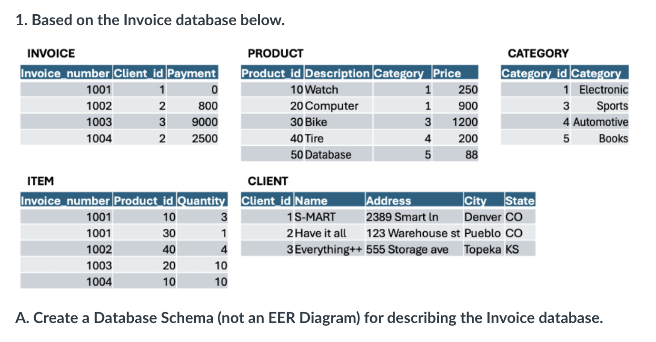
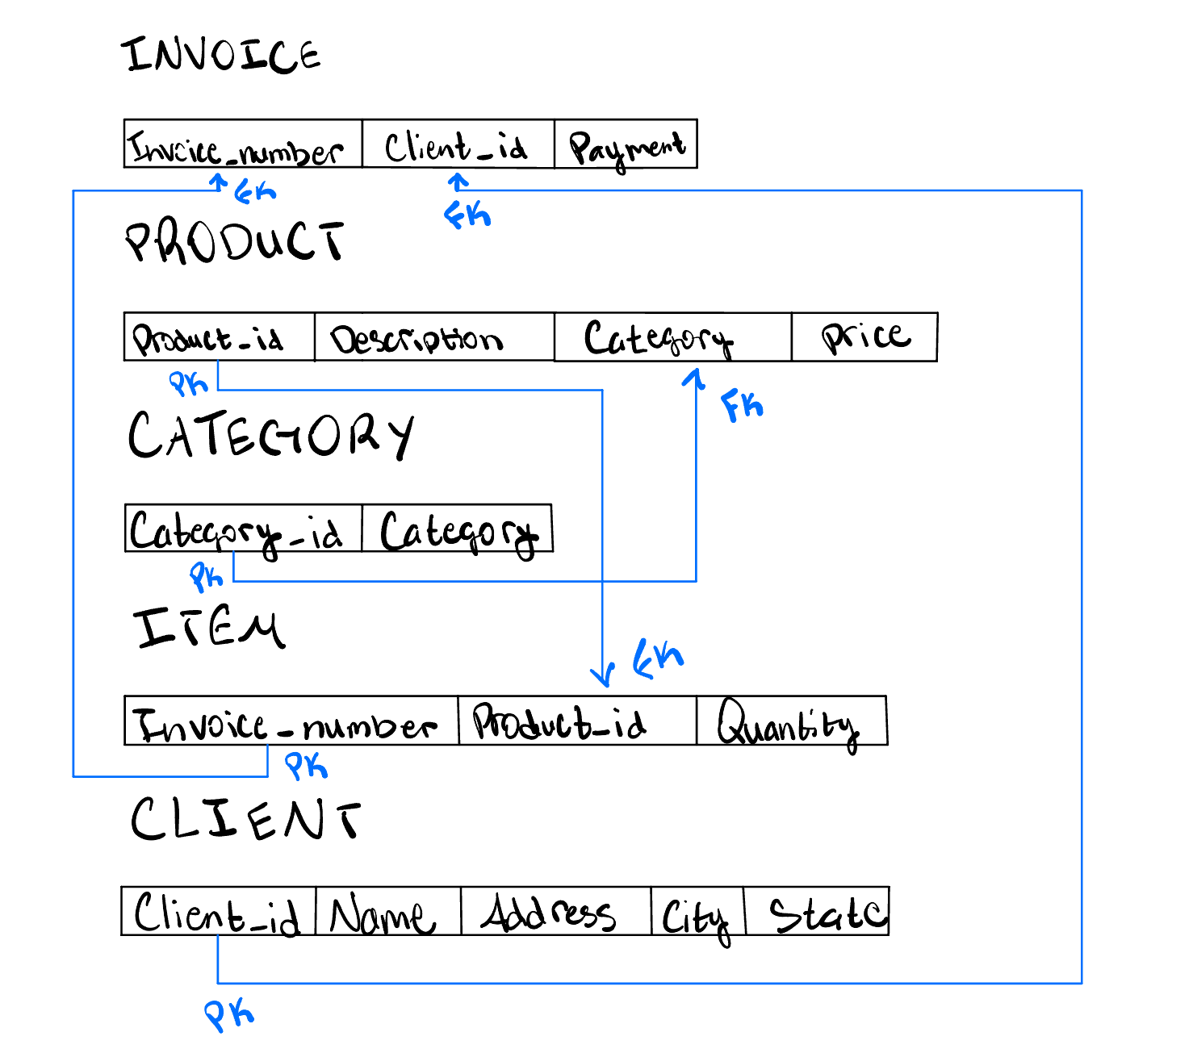
B. Identify the integrity constraints: (1) Key constraints, (2) Entity integrity, (3) Referential integrity or (4) no constraint violation. Discuss all integrity constraints violated by each operation.
a. Insert <1005, 30, 2> into ITEM relation.
- Violations: Foreign Key Constraint
  - Invoice_number 1005 does not exist in INVOICE
b. Insert <60, 'Appliance', 6, 100> into PRODUCT relation.
- Violations: Foreign Key Constraint
  - Category 6 does not exist as a category_id in CATEGORY
c. Update the Product_id attribute of the PRODUCT tuple with Product_id = 50 to 60.
- Violations: NONE
d. Update the Product_id attribute of the ITEM tuple with Product_id = 40 to 60.
- Violations: Foreign Key Constraint
  - Product_id 60 does not exist as a Product_id in PRODUCT
e. Delete the INVOICE tuples with Payment = 0.
- Violations: NONE

2. Create an EER Diagram for a parking garage database.
